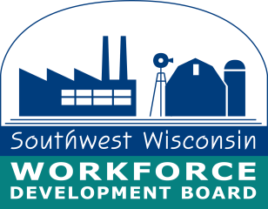

**For Immediate Release**

September 30, 2024

**IN-PERSON JOB FAIR AT THE ROCK COUNTY JOB CENTER**

A Rock County job fair will be held on Wednesday, October 16th at the Rock County Job Center located at 1717 Center Avenue in Janesville. The event will have 29 local employers in attendance and 400+ job openings including seasonal positions and employer representatives that speak Spanish.

Individuals may update and print their resumes in the Resource Room prior to the event. For a complete list of employers, please visit: <https://wisconsinjobcenter.org/events/>.

Individuals having questions can email [DETWDA11BusinessServices@dwd.wisconsin.gov](mailto:DETWDA11BusinessServices@dwd.wisconsin.gov).

**For Additional Information Contact:**

Contact: Gail Graham

Business Services Manager

Rock County Job Center

1717 Center Avenue

Janesville, WI 53545

Phone (608) 314-3300, Ext. 304, Cell: (608) 295-4887

E-mail: g.graham@swwdb.org