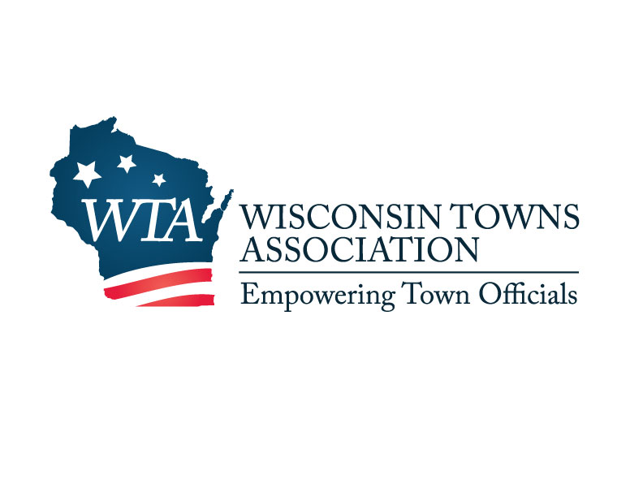

W7686 County Road MMM  
Shawano, WI 54166  
715-526-3157  
wtowns@wisctowns.com  
www.wisctowns.com

For Immediate Release July 11, 2023

Contact: Joe Ruth

WTA Government Affairs Director/Legal Counsel

715-526-3157

**Governor Cuts Town Road Funding**

Using his partial veto authority last week, Governor Evers cut over $10 million in town General Transportation Aid (GTA) funding from the budget passed by the legislature. This came as a shock to town officials as the Governor has both repeatedly indicated he wanted to “fix the damn roads” and also proposed increases in GTA rate per mile in all of his budget proposals, including over a $20 million increase just a few months ago.

General Transportation Aid for towns, cities, and villages is provided on either a rate per mile or share of cost basis. Mileage aid is straightforward, providing municipalities with a set dollar amount per mile of road. The share of cost calculation is more complicated and rewards more spending. The more a community spends the more the state provides them. 1,198 towns (96%) and a couple of villages receive funding through the rate per mile calculation. The Governor’s veto eliminates the rate per mile increases proposed by the legislature, shifting over $10 million to higher spending communities. Due to this veto, no municipality under the rate per mile calculation will see an increase in the next two years – **including almost all towns.**

GTA is the primary source of funding used to plow roads, salt icy highways, mow ditches to prevent deer crashes, patch potholes, and generally provide transportation safety. According to the Governors Highway Safety Association, rural roads are disproportionately deadly: “almost half of all fatal crashes in the United States occur on rural roads – though only 19% of the U.S. population lives in rural areas.” Wisconsin ranks 21st in deaths per 100,000 in population.

The Governor’s veto message stated that this cut is intended to address the disparate impact of 2011 Act 32. This Act cut GTA for larger municipalities because Act 10 provided them with tools to manage costs. While WTA is empathetic to the pressure Act 32 put on share of cost communities, those reductions from a dozen years ago did not benefit rate per mile communities that have lost today. WTA supports finding a long term, sustainable, and equitable solution to funding local roads, but not by reducing the funding of certain local governments to support others.

###