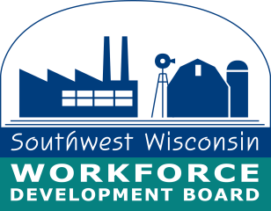

**For Immediate Release**

July 3, 2023

**IN-PERSON JOB FAIR AT THE BELOIT PUBLIC LIBRARY**

An In-Person Job Fair is scheduled for Wednesday, July 19th, 2023 at the Beloit Public Library, 605 Eclipse Blvd. Beloit. 20 employers are registered from Rock county and the surrounding area with a reported 200+ job openings.

The Beloit Public Library is holding "Wednesday's at the Library" on for Wednesday July 19th, 2023 from 11:30 -1p.m. with live music and food trucks outside. Following Wednesday's at the Library, the Job Fair will be held from 1-3 p.m in the Community Room. Job seekers will have access to the public computer lab to complete online job applications and print resumes. A list of registered employers can be found here: <http://wisconsinjobcenter.org/events/>

Individuals having questions can email [DETWDA11BusinessServices@dwd.wisconsin.gov](mailto:DETWDA11BusinessServices@dwd.wisconsin.gov).

**For Additional Information Contact:**

Contact: Gail Graham

Business Services Manager

Rock County Job Center

1717 Center Avenue

Janesville, WI 53545

Phone (608) 314-3300, Ext. 304, Cell: (608) 295-4887

E-mail: g.graham@swwdb.org