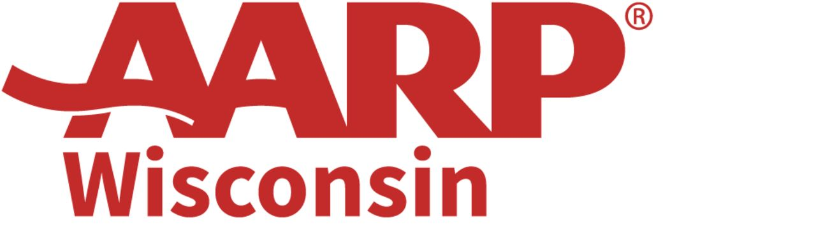

June 28, 2023 / FOR IMMEDIATE RELEASE
Contact: Jim Flaherty, Communications Director
Office 608/ 286-6308 – Cell 608/ 698-0928, jflaherty@aarp.org

AARP awards grants to 6 Wisconsin projects as part of a nationwide program to make cities more livable

$3.6 million in projects across the country will be funded through 2023 Community Challenge grants

MADISON, WI – Today, AARP Wisconsin announces that six projects in five cities throughout the state will receive a combined $84,300 in 2023 Community Challenge grants – part of the largest group of grantees to date with $3.6 million awarded among 310 organizations nationwide.

Grantees in Wisconsin and across the country will implement quick-action projects that help communities become more livable in the long-term by improving public places; transportation; housing; diversity, equity & inclusion; digital access; and civic engagement, with an emphasis on the needs of adults age 50 and over.

In Wisconsin, grants will be awarded to two projects in Milwaukee and one each in Altoona, La Crosse, River Falls and Stevens Point.

“AARP Wisconsin is committed to working with communities to improve residents’ quality of life through tangible changes,” said AARP Wisconsin State Director Martha Cranley. “We are proud to collaborate with this year’s grantees as they make immediate improvements in their communities that will jumpstart long-term change, especially for Wisconsinites 50 and over. Our goal is to support the efforts of our communities to be great places for people of all backgrounds, ages and abilities.”

Here are details of the grants awarded to the six Wisconsin projects:

City of Altoona – With its $10,000 grant, the city will hold an accessory dwellings unit design competition to promote their use as a housing solution. The competition will include an open house and presentations of design concepts to help educate builders and the broader community about ADUs.

City of La Crosse – With its $20,000 grant, the city’s parks, recreation and forestry department plans to revitalize a frequently used route and make it more accessible to residents age 50-plus by adding improvements such as a new crosswalk with art, a covered bus shelter and seats, light posts with decorative banners, and other amenities.

City of Milwaukee – With its $12,000 grant, the city’s department of public works plans to create a traffic calming lending library, giving residents the power to try out traffic safety designs on their street so they can understand which options would most effectively address their concerns.

City of Milwaukee – With its $20,000 grant, the city’s Redevelopment Authority plans to support community outreach for the “Growing MKE” initiative, which will amend the city’s comprehensive plan and update zoning to reduce barriers that interfere with development of housing for older adults.

City of River Falls – With its $10,000 grant, the city will fund safety improvements at a major intersection and demonstrate traffic calming interventions such as high-visibility crosswalk markings and an auditory response system.

City of Stevens Point – With its $12,300 grant, the city will install five age-friendly benches at selected transit stops, all of which have a high degree of usage and are situated along major transportation corridors.

This is the seventh year of the AARP Community Challenge Grant. Wisconsin communities that have received grants in previous years include: Appleton, Ashland, Bayfield, Beaver Dam, Berlin, Chilton, Cuba City, Deer Park, Ellsworth, Gays Mills, Green Bay, Greendale, Goodman, La Crosse, Madison, Milwaukee, Oconomowoc, Sheboygan, Spooner and Viroqua.

AARP Community Challenge grant projects will be funded in all 50 states, Washington, D.C., Puerto Rico, and the U.S. Virgin Islands. Projects must be completed by Nov. 30, 2023. The program is part of AARP’s nationwide Livable Communities initiative, which supports the efforts of cities, towns, neighborhoods and rural areas to become great places to live for people of all ages.

This year, the AARP Community Challenge accepted applications across three different grant opportunities, including existing flagship grants in addition to new capacity-building microgrants for improving walkability and community gardens. New demonstration grants will focus on improving transportation systems and housing choice design competitions. AARP is also bolstering its investment in rural communities, mobility innovation, transportation options, and health and food access.

View the full list of grantees and their project descriptions at aarp.org/communitychallenge and learn more about AARP’s livable communities work at aarp.org/livable.

###

AARP is a nonprofit, nonpartisan organization, with a membership of more than 37 million, that helps people turn their goals and dreams into real possibilities, strengthens communities and fights for the issues that matter most to families such as healthcare, employment security and retirement planning. We advocate for consumers in the marketplace by selecting products and services of high quality and value to carry the AARP name as well as help our members obtain discounts on a wide range of products, travel, and services. A trusted source for lifestyle tips, news and educational information, AARP produces AARP The Magazine, the world's largest circulation magazine; AARP Bulletin; www. aarp.org; AARP TV & Radio; AARP Books; and AARP VIVA, a bilingual news source. AARP does not endorse candidates for public office or make contributions to political campaigns or candidates. The AARP Foundation is an affiliated charity that provides security, protection, and empowerment to older persons in need with support from thousands of volunteers, donors, and sponsors. AARP has staffed offices in all 50 states, the District of Columbia, Puerto Rico, and the U.S. Virgin Islands. Learn more at www.aarp.org.

