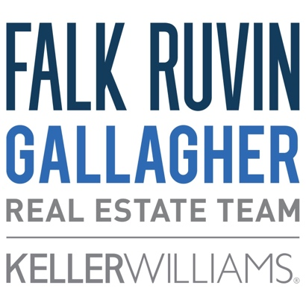
FOR IMMEDIATE RELEASE
Media Contact:
Samantha Henschel
(414) 278-0040
samanthah@stirstuff.com

Falk Ruvin Gallagher ‘Pets at Home’ Program Supports Pet Parents on the Move

Home Barket Report finds many seek home amenities tailored to their furry family members

Milwaukee, Wis. (June 13, 2023) – Eighty-nine percent of Milwaukee-area residents keep their pets in mind when finding the perfect place to live according to a new Home Barket Report, an online poll conducted by Falk Ruvin Gallagher Team of Keller Williams Northshore to learn more about pet parent’s top priorities to ensure their furry family members are comfortable and happy at home.

The Falk Ruvin Gallagher real estate team has launched a ‘Pets at Home’ program offering paw-some resources for local pet parents, especially to ease anxieties for those buying or selling a home. The program offers helpful tips on moving with pets, a local pet services guide with recommendations from Falk Ruvin Gallagher team members, pet-friendly events and partnerships with animal welfare organizations, including the Wisconsin Humane Society.

The team’s goal is to provide regularly updated content on how to find amenities and neighborhoods that help everyone feel at home, including those who bark, sniff, dig and get the zoomies every once in a while.

“Our team of pet lovers understands how important it is to find just the right home environment for our furry best friends and consider their needs when moving and selling,” said Richard Ruvin, lead partner with Falk Ruvin Gallagher.

The Pets at Home program content is informed by the Home Barket Report, an online poll conducted in May with nearly 200 Milwaukee residents. The poll found:
- 57.6% look for in-home amenities, including ample room to roam, durable flooring and large windows.
- 49% expressed the importance of neighborhoods having pet-friendly services close by, including dog parks, veterinarians, pet stores, groomers, pet-friendly restaurants and more.
- 41.9% shared that walkability is important when considering pet-friendly neighborhoods.
- 34.9% of pet parents look for a fenced-in yard.
- 30% said a grooming/pet bathing station is the pet-friendly amenity they’d most love to have in their home.

As part of the ‘Pets at Home’ program, Falk Ruvin Gallagher will host a pet supply drive until Friday, June 16. Stop by the Falk Ruvin Gallagher office any time from 9 a.m. – 4 p.m. to donate moist dog treats, dry or canned cat/dog food, cat litter, peanut butter, potty training pads, unscented baby wipes and/or soft dog toys to a pet in need.

The FRG team is an event sponsor of the Wisconsin Humane Society’s Pet Walk. Join team members at the event on Saturday, June 17, from 8 a.m. – 1 p.m. along with local dog expert Mary Stallman, owner of Dog Training Elite in Glendale, from 11 a.m. – 1 p.m. to hear tips for moving with your dog and advice for pet parents. Stop by FRG’s table for a chance to receive a complementary training session with Dog Training Elite and hear about their commitment to furry family members with the new ‘Pets at Home’ program.

###

About Falk Ruvin Gallagher

With more than 70 years of combined experience, the Falk Ruvin Gallagher Real Estate Team has the expertise, community familiarity, and client network to provide unmatched personal attention in home buying and selling. We excel at the art of bringing buyers and sellers together, often finding creative solutions to get negotiations done smoothly and swiftly. The Falk Ruvin Gallagher Team’s primary market includes Downtown Milwaukee, the North Shore communities in Milwaukee and Ozaukee Counties, and Lake Country.

