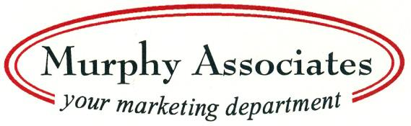

Media Release:

Contact: Judi Murphy, Murphy Associates
p: 262-786-7424
e: judi@marketingwithmurphy.com

Andy Weins, Green Up Solutions, Launches First Book – Amazon Best Seller

Milwaukee, Wis. – June 16, 2023 – Andy Weins, CEO of Green Up Solutions, has written his first book – “Words Fucking Matter – Retrain Your Brain to Use Language that Serves You.” The book became an Amazon Best Seller on June 14, 2023, and will be featured at a book launch party on June 21, 4:00 p.m. – 7:00 p.m. at Hot House Tavern, N88 W16631 Appleton Avenue, Menomonee Falls, Wis. 53051.

“Words Fucking Matter” was released on June 14, 2023, and book signing by Weins will be available at the launch party. Refreshments will be provided by Hot House, and people who bring their already purchased books will be treated to a free drink ticket at the event. To purchase “Words Fucking Matter,” go to https://tinyurl.com/yc5v65fr

Weins said, “I wrote this book because I spent almost 40 years lying to myself about my intentions, expectations, and ideals for myself. Once I started holding myself accountable through language, I started to live a life that I had only dreamed of.”

“Words Fucking Matter” is a transformative guide that will revolutionize the way you communicate. It provides invaluable insights and practical strategies to harness the true potential of your words and create a positive impact in every aspect of life. It will lead to a journey of self-discovery and empowerment with the art of intentional language.

Weins continued,” The most important message of the book is that when you control your language, you control your destiny. It starts by simply understanding that the words we tell ourselves become the reality we live.”

Weins is a business owner, Cardinal Stritch graduate, and Veteran of the U.S. Army. He is an active member of the United States Army Reserve with over 19 years of service, is a combat Veteran of Operation Iraqi Freedom, and is currently a U.S. Army Reserve career counselor.

To purchase “Words Fucking Matter,” go to https://tinyurl.com/yc5v65fr

For more information, contact Andy Weins at 414-793-6253 or aweins@greenupsolutions.org. Green up Solutions is located at 12733 W. Arden Place, Butler, Wis. 53007.

