

AACCW announces winners of RISE MKE Pitch Night

For Immediate Release
July 12, 2021
For more information, contact AACCW Vice President Jona Moore at (414) 462-9450 or jmoore@aaccwisconsin.org

MILWAUKEE – The African American Chamber of Commerce of Wisconsin (AACCW) announces the winners of its RISE MKE Pitch Night, which awards cash to help budding entrepreneurs launch and grow their ventures.

Melissa Blue Muhammad, founder of Allah Mode, is the recipient of the first place award. Allah Mode provides hand-crafted, wearable art featuring precious metals and healing crystals.

Marie Carter, founder of The Classic Shoppe, is the recipient of the second place award. The Classic Shoppe produces statement apparel.

Pamela McCreary, founder of At Peace Designs, is the recipient of the third place award. At Peace Designs’ products include stickers, bracelets, earrings, shopping bags, mugs and masks.

Bianca Nelson, founder of 3B’s Catering, is the recipient of the fourth place award. 3B’s Catering is a home-based catering company specializing in family dinners and jarred desserts.

The winners of the Rise MKE Pitch Night competition received combined cash awards of $10,000 provided by Advocate Aurora’s Health’s Better Together Fund to help grow their companies.

“Each of the winners of the Pitch Night competition demonstrates the traits needed to grow a sustainable business, and our organization is proud and happy to help them with their ventures,” said Ossie Kendrix, president and CEO of the African American Chamber of Commerce of Wisconsin.
The winners of Pitch Night led the graduating class of the AACCW’s 2020-21 RISE MKE program, which provides 14 weeks of entrepreneurial training for emerging businesses.

“RISE MKE provides business development with focuses on marketing, branding, business network development and other essential resources,” Kendrix said.

In addition to Muhammad, Carter, McCreary and Nelson, other new graduates of the RISE MKE Cohorts 4 and 5 program include: Brittni Patterson of Busy B Laundry; Carla Washington of LevelUp Staffing and Training; Edna Hale of Hale Healthcare Products & Services LLC; Harry Evans of HE Trains LLC; Jeremy Triblett of Jeremy Triblett LLC; Juwania Keys of POPtherapy; Kenisha Hayward of Hayward & Dye LLC; Lakeisha Johnson of Barely Used; Miya Owens of Naturally Bliss; Brianna Richmond of A Sunflower Soul; Devon Gibson of Mr. DoItAll; Donna Owens of Delectables by Donna Catering; Ebony Whitson of Whitson Wonder Productions; Lavance Crisler of Reliant Property Management; Pierre Ndongue of EcoClean LLC.

“RISE MKE is designed to positively impact African American entrepreneurs who are starting or growing their businesses and give them the tools they need to be successful during this pandemic and beyond,” Kendrix said.
Once the cohorts complete the program, they become RISE Alumni and continue to receive support in workshops through the AACCW. The workshops are facilitated by consultants and cover topics such as strategic planning, branding, preparing for business growth and succession planning.

“These workshops are provided to continuously support the growth and sustainability of the minority businesses and entrepreneurs that come through RISE MKE,” Kendrix said. “RISE MKE is now preparing for Cohorts 6 & 7 and Cohorts 8 & 9 to begin in late summer. These additional cohorts will run simultaneously and will have the capacity for 18 entrepreneurs per cohort,” Kendrix said.

For more information about applying to enter the RISE MKE program, contact the AACCW at 414-462-9450.

The African American Chamber of Commerce of Wisconsin champions the growth and sustainability of African American-owned businesses by providing access to capital, education and advocacy through capacity building and strategic partnerships.
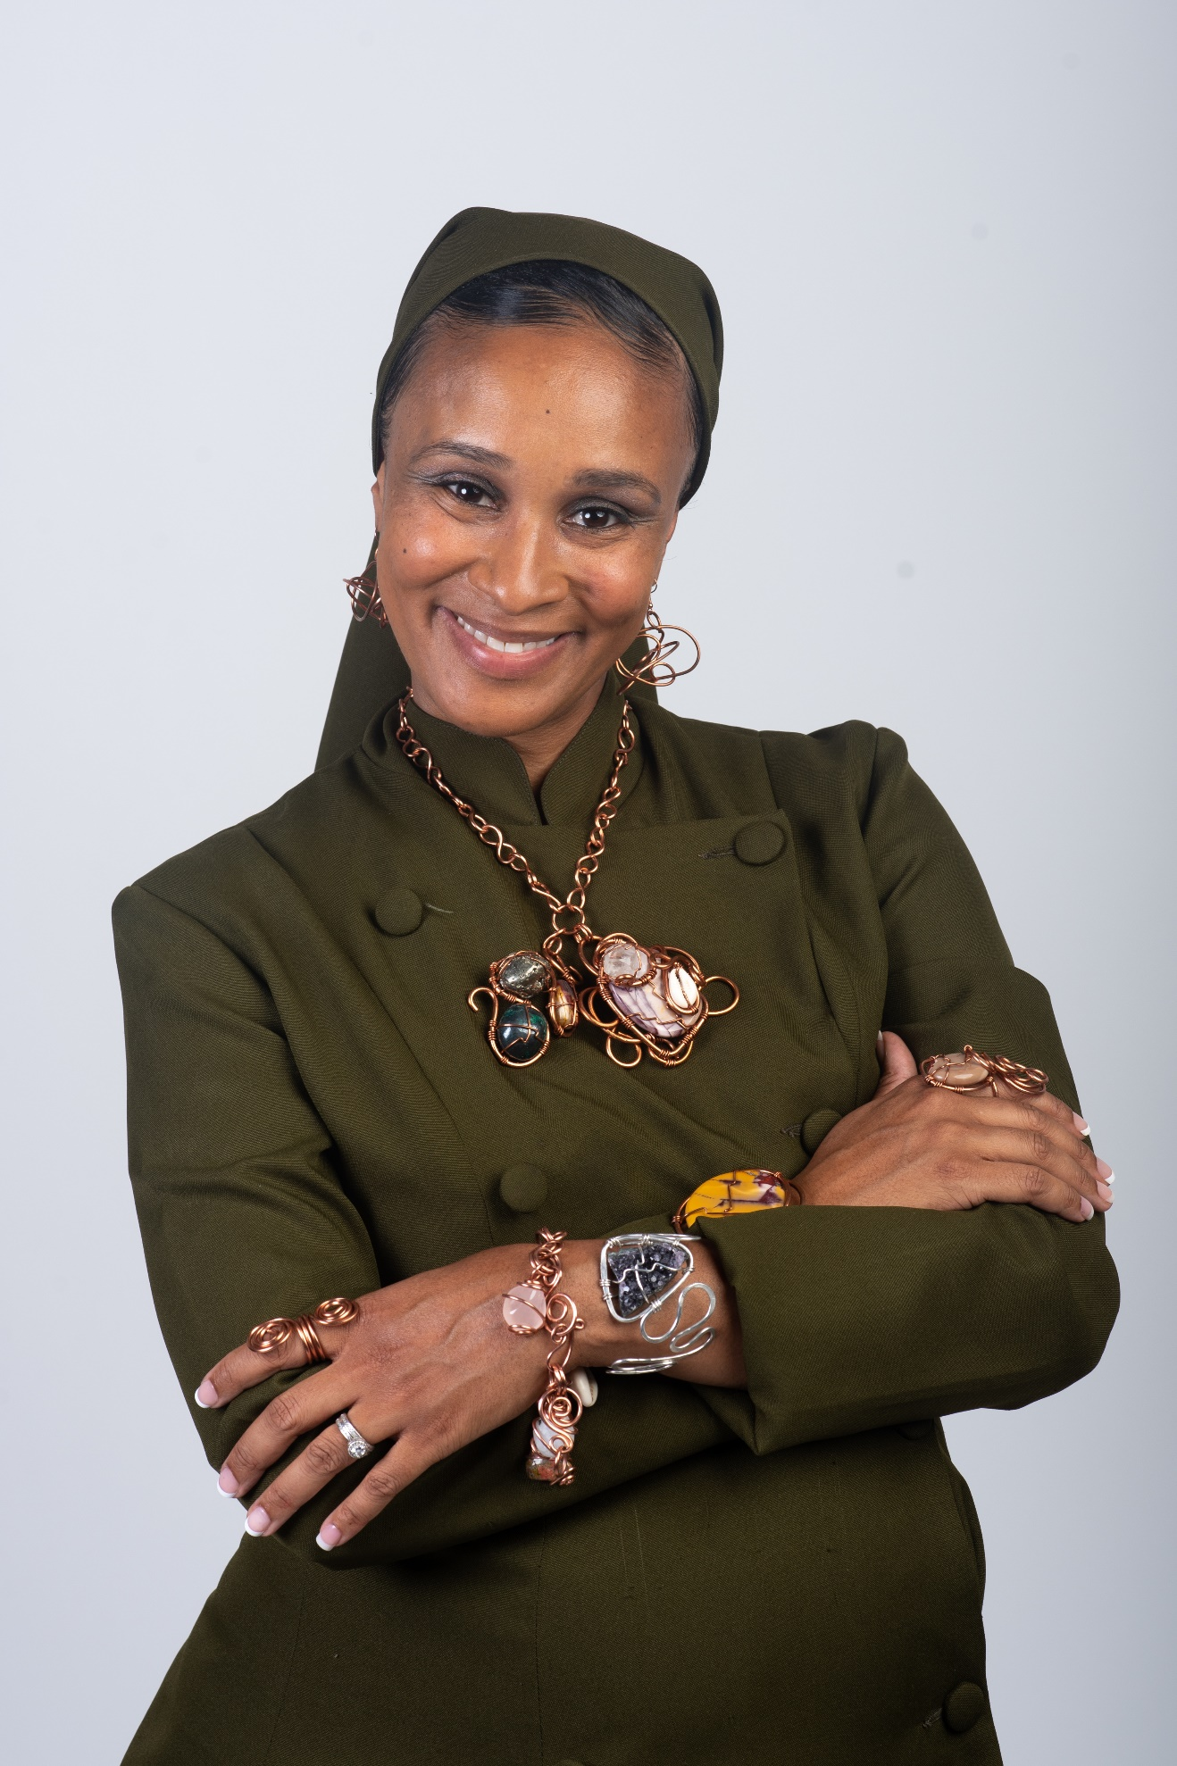
Melissa Blue Muhammad

- 30 -

