FOR IMMEDIATE RELEASE

Boelter + Lincoln Adds Dietz, Lovdal

MILWAUKEE (May 11, 2021) – Boelter + Lincoln Marketing Communications has hired Johnny Dietz as a digital media assistant and Lizzi Lovdal as an assistant account executive.

An Elm Grove native, Dietz graduated from the University of Minnesota in 2017 with a bachelor’s degree in business and marketing education. He previously worked at Margle Media and Tuna Traffic. In his free time, Dietz runs a travel social media account called Fascinating Locations.

Lovdal hails from New Berlin and will be graduating from Marquette University in late May with a bachelor’s degree in public relations and a minor in marketing. Before coming to B+L, she worked at DeafandHoH, LLC as a marketing intern and at Lessiter Media as an editorial intern. While in college, Lovdal was active in the Public Relations Student Society of America (PRSSA).

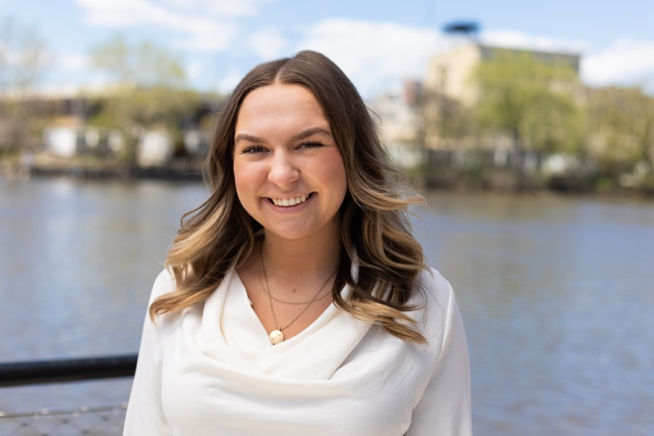

Lovdal Dietz

Boelter + Lincoln is a full-service marketing communications firm with more than 45 years of award-winning experience.
# # #

