The board of directors of the Wisconsin Technology Council, voting January 14, 2021, resolved to the following:

WHEREAS, the Wisconsin Technology Council was incorporated in 2001 to serve as the non-profit, non-partisan science and technology adviser to the Governor and the Legislature, and;

WHEREAS, the Tech Council has consistently encouraged policies based on sound science; that support high-tech research and technology transfer; and that encourage the growth of Wisconsin’s tech-based economy, and;

WHEREAS, the Tech Council issued position papers in 2020 related to the COVID-19 pandemic in the state, focusing on business reopening strategies; the prospects for the widespread availability of a vaccine; and the importance of wearing masks and following other public-health protocols to mitigate the spread of the disease, and;

WHEREAS, vaccines have been described by the World Health Organization as having accomplished more to reduce deaths, disabilities, and illness than any public health advance in history except for clean water, and;

WHEREAS, the recent development of safe, effective COVID-19 vaccines involved many of the world’s leading experts in a concentrated effort backed by billions of dollars in public support in the United States alone, and;

WHEREAS, all vaccines are reviewed rigorously for safety and efficacy by the U.S. Food and Drug Administration, with the oversight of its external review boards, a process that stands as the world’s gold standard, and;

WHEREAS, the FDA has approved two COVID-19 vaccines for emergency use and may approve others, and;

WHEREAS, the FDA-approved vaccines were developed with customary clinical trial enrollments; all stages of clinical trials were carefully executed with proper oversight; and effectiveness in preventing COVID-19 was determined to be 90 to 95 percent, and;

WHEREAS, the Tech Council board of directors includes members from business, academia, investment entities, service firms, economic development and the health sciences, including organizations that have independently reviewed the submissions for clearance and FDA’s regulatory conclusions, and;

WHEREAS, while vaccines and pharmaceuticals have some reported adverse events, serious adverse events have been rare and treatable after millions of doses administered. Clinically proven benefits greatly outweigh the risks. Vaccines cannot help if they remain inside vials and are not put to work in human bodies; and,

WHEREAS, public health recommendations such as social distancing, masks and frequent hand washing should continue to be followed during the nationwide vaccination rollout, and:

WHEREAS, widespread COVID-19 vaccination will greatly enhance economic recovery. Public confidence will be restored; businesses of all types can get back to business; and many jobs sidelined by the virus may return; therefore;

BE IT RESOLVED that the board of the Tech Council:

- Advises Wisconsin elected officials and the citizens of Wisconsin of its high confidence in the completeness of pre-clinical and clinical trials, as well as the rigor and standards applied by the FDA to approve COVID-19 vaccines, and;
- Advises Wisconsin elected officials and the citizens of Wisconsin of its high confidence in the safety and effectiveness of the vaccines as determined by the FDA in its approval of the vaccines, and;
- Recommends that as many Wisconsin citizens as possible become vaccinated against the COVID-19 virus as soon as possible under priority guidelines and as advised by their personal physician, and;
- Recommends that Wisconsin’s elective bodies adopt no legislation or make any collective statements that would serve to undermine the public’s confidence in the science behind the safety and effectiveness of FDA-approved COVID-19 vaccines, and;
- Pledges that its individual directors will choose to be vaccinated as soon as allowed to do so under priority guidelines and as advised by their personal physicians.

Respectfully submitted by:

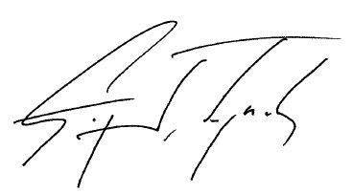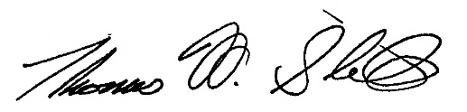

Greg Lynch, chairman Tom Still, president
Wisconsin Technology Council Wisconsin Technology Council

