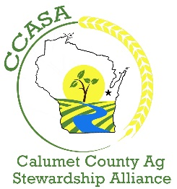
FOR IMMEDIATE RELEASE
Aug. 11, 2020
Contact: Steven Schauer
Dairy Strong Sustainability Alliance
(920) 471-9896 | sschauer@voiceofmilk.com

Calumet County Ag Stewardship Alliance
to host field day
Farmer-led watershed group to show best manure practices Aug. 25
CHILTON, Wis. — Calumet County Ag Stewardship Alliance will host its first field day event on Aug. 25 to demonstrate and discuss manure infiltration into the soil.

The farmer-led watershed conservation group is inviting agricultural industry professionals and interested residents to learn more about how certain application practices affect manure infiltration. There will be multiple stations and three soil pits will include comparisons between the following manure application techniques: pretillage with incorporation vs. incorporation only, pretillage with top dress vs. top dress only, and two minimum-disturbance toolbars. The field day will also include plots with various techniques of incorporating manure with cover crops, such as pre- plant application and post-plant application.

For safety from coronavirus, groups of fewer than 10 people will be allowed per station with 6-foot physical distancing. Masks are recommended and will be provided.

MEDIA

News reporters wanting help connecting with farmers at the event should contact Steven Schauer, communications specialist at the Dairy Strong Sustainability Alliance, (920) 471-9896 or sschauer@voiceofmilk.com.

CCASA Logo

IF YOU GO
When: 1-3 p.m. Aug. 25
Where: Corner of County Highway E and Twain Road (Chilton, Wis.)
Cost: Free
Register by Aug. 24 at https://tinyurl.com/ccasa2020.
About the Calumet County Agriculture Stewardship Alliance

Calumet County Ag Stewardship Alliance is a nonprofit group of innovative farmers, committed community members and other professional partners dedicated to championing sustainable farming practices that protect water quality and build healthy soil.

# # #

