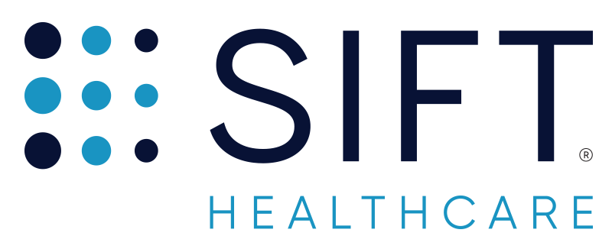

FOR IMMEDIATE RELEASE

Contact: Bethany Grabher

VP, Marketing & ACCOUNTS bethany@SIFTHEALTHCARE.com

Sift Healthcare Secures $2.8 Million in funding
Financing to fund growth of Sift’s data science team and drive accelerated product development.

MILWAUKEE, WI, August 5, 2020 -- Sift Healthcare, a Milwaukee-based data science and analytics company that brings AI to healthcare payments, has announced $2.8 Million in new funding. $1.875 Million of this funding is new equity from investors that include Rock River Capital Partners and the Winnebago Seed Fund, who was an early investor in Sift, leading Sift’s seed round of fundraising in November 2017.

Sift closed this over-subscribed round of funding in late July. New funds will be used to expand Sift’s data science and data engineering teams, creating the bandwidth required to meet the demand of Sift’s growing sales pipeline and to further develop Sift’s AI-based solutions for the revenue cycle.

“We are honored to have committed investors who recognize the timely opportunity to innovate in the healthcare payments space,” said Justin Nicols, Sift’s Founder and CEO, “I am particularly proud that our investors are Wisconsin-based and committed to growing tech companies within our state.”

Along with new funding, Sift is also proud to announce a partnership with State Collection Service. Based in Madison, Wisconsin, State Collection Service is one of the country’s leading healthcare receivables companies. State Collection Service has signed a 3-year enterprise-level contract to deploy Sift's AI-based solutions and analytics.

“State has run rigorous tests with Sift and the results we’ve seen have been significant. We’re excited to add the power of Sift’s data science and analytics to our tech stack," commented Tim Haag, President of State Collection Service, “State has a long history of bringing best-in-class technology to the receivables industry and Sift’s solutions will help further this commitment to innovation.”

Founded in 2017, Sift brings data science to healthcare payments, using AI and machine learning to accelerate insurance reimbursement, personalize patient collections strategies and improve revenue cycle efficiency. To learn more please visit www.sifthealthcare.com.

About Sift Healthcare
Sift Healthcare is a Milwaukee-based healthcare payments analytics and data science company. Sift’s data platform, dashboards and reporting, machine learning integrations and C-Suite intelligence tools equip healthcare providers and RCMs with meaningful insights and powerful workflow enhancements for the revenue cycle.

Follow Sift Healthcare:
www.sifthealthcare.com
www.linkedin.com/company/sift-healthcare

###

