Press Release

For Immediate Release
August 10, 2020

Dawn Tryba
Chief Marketing Officer
Trybadd@yahoo.com
(262) 672-7953
https://www.linkedin.com/in/dawn-d-tryba2019/

Airoldi Brothers, Local Family Business Expands Services,
to better Support Customer Needs in Transportation Industry,
and Build Employment Opportunities in Local Markets

(Milwaukee, WI) – Recently, Airoldi Brothers NationaLease expanded services through acquisition of six locations of McCoy NationaLease in Janesville, WI, Appleton, WI, Green Bay, WI, Milwaukee, WI, Rockford, IL, and Minneapolis, MN.
“This sale will expand Airoldi’s reach in the market and our footprint in the industry, allowing us to service more prospective customers, continue to support existing clients, and provide job opportunities in local markets,” says Cheri Airoldi, Co-Owner - Airoldi Brothers.
With more than 50 years of service in the local market, McCoy has longstanding relationships in the community and a well-founded reputation in the industry. McCoy NationaLease is a part of The McCoy Group, which was founded in 1958 by Robert McCoy. They provide full-service commercial truck leasing, rental and contract.
The Appleton location will operate as a duplicate location for Airoldi Brothers, expanding service operations in the area, while managing different maintenance roles. The Milwaukee location will be merged into Airoldi’s existing location while IL, MN, Janesville, WI and Greenbay, WI will serve as new business locations for Airoldi Brothers.
“The team of McCoy employees have a strong work ethic and dedication to the company. We are fortunate to have such a strong group of people that will complement the Airoldi brand, says Mike Airoldi, Co-Owner – Airoldi Brothers.
Airoldi is not planning any layoffs from the acquisition of McCoy and in fact expect to add more employees over time to ensure quality service to customers.
“We have the ability to extend our customer-centric support model to a group of existing customers and continue our longevity in the truck leasing industry,” says Mike Airoldi, Co-Owner – Airoldi Brothers. “Making sure we take care of our customers and employees is of the highest priority”, adds Mike.
The new location in Green Bay helps Airoldi service customers that were hard to get to in the past with a primary Milwaukee location. The ability to provide Reciprocal Service work brings together purchasing power and support in a local market for better service where they can train local mechanics to conduct road calls.
“We have been interested in expanding our services for quite some time, moving the company forward and evolving the business. Strength and growth come only from continuous effort.” says James Airoldi, Co-Owner – Airoldi Brothers.
This is yet another strategic sales and marketing ploy Airoldi has deployed to position the company for success. Five years ago, the company purchased trucks and a customer base from Siva Truck Lease in Milwaukee, WI. In addition, over the past few years, they have made several other small acquisitions of privately owned companies to add to their fleet of services.
The leadership team at Airoldi Brothers is fast to respond to questions, concerns or business needs. From staffing and training to safety and technology, they make every decision based on what is best for the customer. This is just one of the reasons Airoldi has a 98% customer retention rate and enjoys long-standing customer relationships that date back decades.
For over 80 years, Airoldi Brothers has provided innovative truck leasing solutions to customers of all sizes—from small businesses to large fleets. With a focus on exceptional customer services, every member of the Airoldi team is committed to meeting the needs of customers and making their job easier. They are a family-owned and operated business who strives to make sure customers feel like part of the family.
Whether customers need one-truck or an entire fleet, Airoldi Brothers can provide an excellent solution through truck rental, leasing and services located in Milwaukee, Oak Creek, Green Bay, Janesville, Madison, Appleton, Kenosha and LaCrosse, WI, Rockford, IL and Minneapolis, MN.

Important Truck Leasing Industry Statistics:
- The truck leasing industry in the U.S. pulls in about $21 billion in revenues each year and the industry experienced an average annualized growth rate of 3.3%. (Source: IBIS World).
- With an estimated 12,000 businesses currently operating in the truck leasing sector in the U.S., more than 77,000 direct employment opportunities have been created. (Source: IBIS World)
- 1 in 4 trucks that is on the road in the U.S. comes from an agency working with the truck leasing industry. (Source: Truck Renting and Leasing Association)
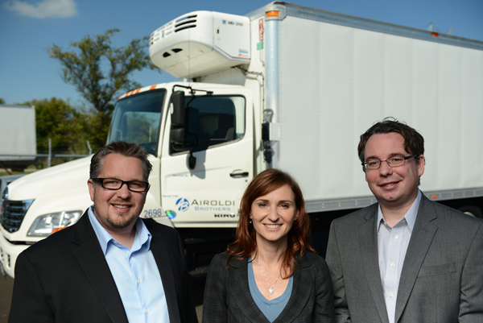
(L-R) Mike Airoldi, Co-Owner - Cheri Airoldi, Co-Owner - James Airoldi, Co-Owner

Airoldi Brothers, Inc.
6930 South 6th Street
Oak Creek, WI 53154
1-800-952-7068 | 414-856-0508
info@airoldibrothers.com
http://airoldibrothers.com/

###

