FOR IMMEDIATE RELEASE
Aug. 3, 2020
Contact: Jamie Mara | (920) 209-3990 | jmara@voiceofmilk.com

DBA and Edge ‘Policy Picnics’
connect dairy farmers with key issues
Latest events in South Dakota, Wisconsin empower members
GREEN BAY, Wis. — Engaging farmers and others in the dairy community in the legislative process and empowering them to stay connected with issues that affect what they do and how they do it is a key goal of the Dairy Business Association and Edge Dairy Farmer Cooperative.
The groups’ use of Policy Picnics continues to be an effective way to accomplish this with members, who appreciate getting the latest information.
“Aside from the (coronavirus) concerns, some of us farmers are unsure of the reasons for the huge dip in the milk price recently,” said Tiffany Kohlmann, who milks 240 cows with her family near Clarksville, Wis.
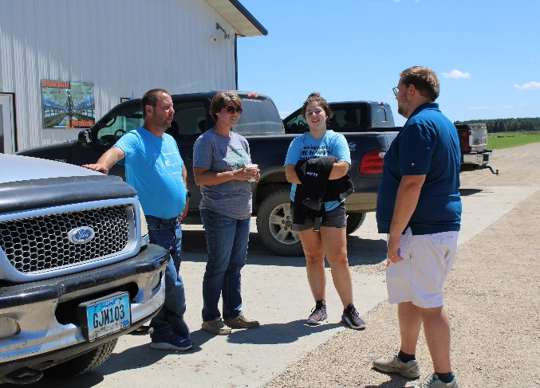
Kohlmann was among dozens of DBA and Edge members who attended a Policy Picnic on July 16 at Shiloh Dairy in Brillion, Wis. Edge also held one of the events on July 28 at MoDak Dairy near Goodwin, S.D. Edge and DBA are sister organizations based in Green Bay, Wis., that together represent farmers throughout the Midwest in fighting for effective government policies at the state and federal levels.
Kohlmann said she thinks it’s vital for DBA and Edge to advocate for farmers’ needs. She said farmers have had the same inputs as always, but their expenses have increased while their profit has decreased.
“Store prices kept going up, but the farmer was not seeing that money,” she said of the earlier days of the pandemic. “It’s important for Edge and DBA to get involved to make sure that dollar from the consumer is passed down to the farmer, so that we can actually continue providing a nutritional product for the most efficient price.”
Building connections
At the picnics, members hear from the groups’ government affairs team, including a consultant from Washington, D.C., and chat one-on-one with other staff members, lawmakers and fellow farmers.
Members and staff both benefit from the interaction, Tim Trotter, executive director of DBA and Edge, said.
“The picnics are a great resource for both groups to get information and ideas from each other as well as connect on the policy issues,” Trotter said. “They are designed to be an informal gathering, as you would expect in rural communities, … and sometimes that’s where you get the best ideas and input.”
Trotter said farmers love the chance to network and share ideas about their businesses with each other and also engage more personally with staff.
“Building strong connections and prioritizing two-way communication is crucial for the organizations and the members,” he said. “We pride ourselves on being in close contact with our members, so engagements like this give us that point of contact. This is also a great opportunity to meet people and catch up.”
The chance to interact with lawmakers is also important, Trotter said.
“With the legislators in attendance, it’s all about the engagement aspect of it,” he said. “You move policy by engagement and by having that legislator or staff person creating a personal relationship with constituents, and in this case the constituents are dairy farmers.”
Jeremy Natzke, owner of Wayside Dairy in Greenleaf, Wis., appreciated being able to put faces with names at the Shiloh Dairy event.
“Creating a personal relationship helps keep legislators involved and provides a better understanding of the farmer perspective,” he said. “I have to speak up for myself.”
Making voices heard
Learning what issues will affect day-to-day farm operations and what to do more research on is a priority for Heidi Fischer, who helps run Fischer-Clark Dairy Farm in Hatley, Wis., and also serves on Edge’s board of directors.
Fischer said having a proactive voice in agriculture is critically important.
“People (including most lawmakers) really don’t know what’s happening on the farm, so the more we can make our voices heard, the more they will know about how this stuff truly impacts us as farmers,” Fischer said.
In addition to the direct connection between members and staff the Policy Picnics provide, Fischer said these engaging get-togethers are crucial to help ensure policies are sensible, whether on the state or federal levels.
“I also think it’s a way to just show everybody where our (groups’) activism is and how we’re spending our time.”
Tweet about this: #Dairy groups @voiceofmilk @DairyForward connect farmers with key issues at ‘Policy Picnics’ https://bit.ly/2Dk3QS6 #DairyForward #TheVoiceOfMilk
Photos:
Aaron Stauffacher, associate director of government affairs for the Dairy Business Association and Edge Dairy Farmer Cooperative, talks about federal issues at a Policy Picnic held by the groups on July 28 at MoDak Dairy near Goodwin, S.D.
John Holevoet, (right) director of government affairs for the Dairy Business Association and Edge Dairy Farmer Cooperative, talks with Edge members Richard, Michelle and Kayla Schweer at a Policy Picnic held by the groups on July 28 at MoDak Dairy near Goodwin, S.D. The Schweer dairy farm is located in Milbank.
Video:
Cassandra Kuball, who works with Michael Torrey Associates in Washington, D.C., a partner with Edge Dairy Farmer Cooperative, talks about progress on U.S. trade agreements as well as the process for updated federal dietary guidelines. Kuball joined the Edge’s members for a Policy Picnic on July 16 at Shiloh Dairy in Brillion, Wis.
About DBA:
The Dairy Business Association is the leading dairy lobby group in Wisconsin, focused on advocating for sensible state laws and regulations that affect the dairy community. The nonprofit organization is comprised of dairy farmers, milk processors, vendors and other business partners who work collaboratively to ensure that dairy farms of all sizes have the support they need to keep America’s Dairyland strong. More information: www.dairyforward.com.

About Edge:
Edge Dairy Farmer Cooperative provides dairy farmers throughout the Midwest with a powerful voice — the voice of milk — in Congress, with customers and within their communities. Edge, based in Green Bay, Wis., is one of the top cooperatives in the country based on milk volume. More information: www.voiceofmilk.com.

# # #

